Introduction

OVERVIEW
This is a chat application that does not use the Internet. Start a conversation with a stranger sitting close by you, within the range of your device's WiFi signals.
Are you a regular international traveler? In most cases you barely have internet access while you wait at the airport terminal. Simply enable WiFi (Android 4.1 and above) or WiFi Direct (Android 4.0 or below) from the system settings and start the WiFi Social application. You need not be connected to any WiFi hotspot.
You can either choose to set your WiFi Social profile so that others can find you or choose to be anonymous.
You can choose who you like to talk to by selecting their gender and age or choose to chat with anyone.
Use WiFi Social anywhere. Turn airports, train stations, malls etc into a social gathering.

With the availability of mobile computing devices, mobile users have a natural tendency to share information between them. Often mobile users want to have a meeting, even though it is not planned in advance and there is no Internet connection available. For instance, there may be situations that employees find themselves together in a meeting room, or friends or business acquaintances may encounter each other in an airport terminal, or some scholars and researchers may meet in a hotel ballroom for a conference or workshop. In those situations, requiring each user to connect to a wide area network to communicate with each other may not be convenient or practical because of the lack of Internet connectivity or because of the time or cost required for such a connection, So in those situations the “WiFi Chat Room” would help the employees to send and receive the information whit the employees want to share. This application will be based on “Android Operating system”. The chat messages sent are of two types:

1. Public Chat Messages

2. Private chat Messages

We are talking not only about public Wi-Fi networks. Actually, on the modern smart phones you can open Wi-Fi access right on the phone. For WiFi chat you do not need connect other people to your access point. It plays a role of presence sensor only. The name for your own Wi-Fi network is a hook (or place holder) for some forum and web chat.
Actually, WiFiChat is a side effect of our new system - Spot Expert. Spotex uses ideas of proximity as a service and lets you define your own messages (data) associated with Wi-Fi access points. It is a context-aware browsing application where Wi-Fi access points your own phone.

Description:
WiFi chat is a new approach for local communications in mobile world. WiFi proximity is a main idea behind WiFi chat. If you and your potential pal can see at this moment the same WiFi access point (WiFi network) than it is very probably that you can see each other. In other words, it is very likely that you are close to each other. Close in the geographical sense, of course.
So, WiFiChat lets you create discussions (forums) as well as live web chats associated with WiFi access points.
The designed system control and monitor System activities, the system is 100% applicable any Network environment, it is three tire architecture Clients, Business Logic, server we have designed custom protocol to control the running system activities and, when the clients become active they will be connected with server and performing task as assigned by the users, and receive the active client information that will send back to the users by the server, server must be active .
It is totally platform Independent System, Behave with server as custom client, it may use custom protocol talk with we have designed custom protocol to control the running system activities and, when the clients become active they will be connected server and performing task as chatting to peoples. The software that automatically repels an unauthorized Clients.

Objective

The main objective of this project is to connect different people that are in the range of same Wi-Fi access point. This will be completely free and no external source of internet will be needed. The chat will be public, means messages will be broadcasted to every user that is connected. This application will be developed in the Java programming language using the android software development kit(SDK).The development platform or integrated development environment(IDE) is eclipse using the android development tools(ADT) Plug-in. We will develop an application where user does not need any web browser to chat with other user. It has its own user interface. The user can connect to any available Access Point for chat with another user connected with same access point. Tethering and portable hotspot utility available on android can also be used for creating an access point. User Datagram Protocol (UDP) is used for sending the packets across the network.

3
Public messages are delivered to all other chat clients nearby, while private messages are directed to a specific recipient. As in most chat applications, there is no history and clients do not expect to receive messages sent earlier or when disconnected. Disconnection can occur at any time while clients are exchanging messages.

Proposed methodology

ANALYSIS PHASE

1)Analysis different application already available in market.

2)Study to make new application for user

DESIGN PHASE

1)Make Data flow Diagram.

2)Make Use Case Diagram.

4)Make Activity diagram.

CODING PHASE

TESTING PHASE

1) Program Testing

2)Module Testing

3)Testing the responsiveness of the system.

BASIC NETWORKING BACKGROUND

NETWORKS
A network is a collection of computers and other devices that can send data to and receive data from each other, more or less in real time. A network is normally connected by wires, and the bits of data are turned into electromagnetic waves that move through the wires. However, wireless networks that transmit data through infrared light or microwaves are beginning to appear; and many long-distance transmissions are now carried over fiber-optic cables that send visible light through glass filaments. There's nothing sacred about any particular physical medium for the transmission of data.
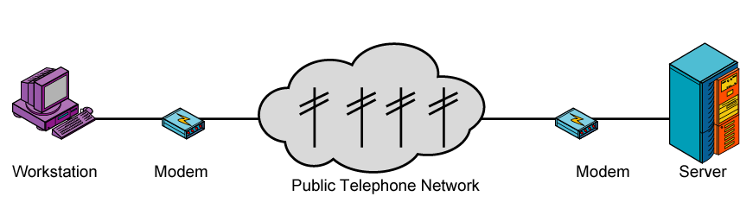

Figure 2.1 Transmission of data through network
Each machine on a network is called a node. Nodes that are fully functional computers are also called hosts. We will use the word node to refer to any device on the network, and the word host to refer to a node that is a general-purpose computer. Every network node has an address: a series of bytes that uniquely identify it. You can think of this group of bytes as a number, but in general it is not guaranteed that the number of bytes in an address or the ordering of those bytes (big-endian or little-endian) matches any primitive numeric data type in Java. The more bytes there are in each address, the more addresses there are available and the more devices that can be connected to the network simultaneously. On some kinds of networks, nodes also have names that help human beings identify them. At a set moment in time, a particular name normally refers to exactly one address. However, names are not locked to addresses. Names can change while addresses stay the same, or addresses can change while the names stay the same. It is not uncommon for one address to have several names; and it is possible, though somewhat less common, for one name to refer to several different addresses. All modern computer networks are packet-switched networks. This means that data traveling on the network is broken into chunks called packets, and each packet is handled separately. Each packet contains information about who sent it and where it's going. The most important advantage of breaking data into individually addressed packets is that packets from many ongoing exchanges can travel on one wire, which makes it much cheaper to build a network: many computers can share the same wire without interfering. (In contrast, when you make a local telephone call within the same exchange, you have essentially reserved a wire from your phone to the phone of the person you're calling. When all the wires are in use, as sometimes happens during a major emergency or holiday, not everyone who picks up a phone will get a dial tone. If you stay on the line, you'll eventually get a dial tone when a line becomes free. In some countries with worse telephone service than the United States, it's not uncommon to have to wait half an hour or more for a dial tone.) Another advantage of packets is that checksums can be used to detect whether a packet was damaged in transit. We're still missing one important piece: some notion of what computers need to say to pass data back and forth. A protocol is a precise set of rules defining how computers communicate: the format of addresses, how data is split into packets, etc. There are many different protocols defining different aspects of network communication. For example, the Hypertext Transfer Protocol (HTTP) defines how web browsers and servers communicate; at the other end of the spectrum, the IEEE 802.3 standard defines a protocol for how bits are encoded as electrical signals on a particular type of wire (among other protocols). Open, published protocol standards allow software and equipment from different vendors to communicate with each other: your web browser doesn't care whether any given server is a UNIX workstation, a Windows box, or a Macintosh because the server and the browser both speak the same HTTP protocol regardless of platform.

THE LAYERS OF A NETWORK
Sending data across a network is a complex operation that must be carefully tuned to the physical characteristics of the network as well as the logical character of the data being sent. Software that sends data across a network must understand how to avoid collisions between packets, how to convert digital data to analog signals, how to detect and correct errors, how to route packets from one host to another, and more.
The process becomes even more complicated when the requirement to support multiple operating systems and heterogeneous network cabling is added. To make this complexity manageable and to hide most of it from the application. There are several different layer models, each organized to fit the needs of a particular kind of network. This book uses the standard TCP/IP four-layer model appropriate for the Internet, shown in Figure 2.2. In this model, applications such as Netscape Navigator and Eudora run in the application layer and talk only to the transport layer.
The transport layer talks only to the application layer and the internet layer. The internet layer in turn talks only to the host-to-network layer and the transport layer, never directly to the application layer. The host-to-network layer moves the data across the wires, fiber-optic cables, or other medium to the host-to-network layer on the remote system, which then moves the data up the layers to the application on the remote system.
For example, when a web browser sends a request to a web server to retrieve a page, it's actually talking only to the transport layer on the local client machine. The transport layer breaks up the request into TCP segments, adds some sequence numbers and checksums to the data, and then passes the request to the local internet layer. The internet layer fragments the segments into IP datagram of the necessary size for the local network and passes them to the host-to-network layer for actual
Transmission onto the wire. The host-to-network layer encodes the digital data as analog signals appropriate for the particular physical medium and sends the request out the wire, where it will be read by the host-to-network layer of the remote system to which it's addressed.

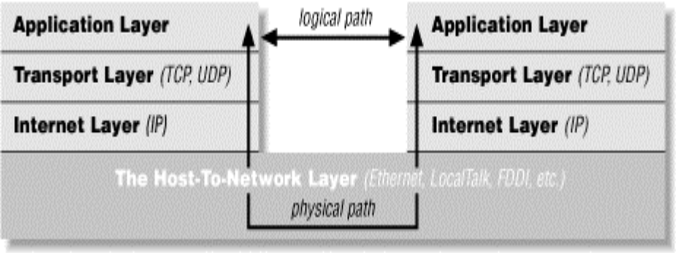
Figure 2.2 Hosts to Network Layer

The host-to-network layer on the remote system decodes the analog signals into digital data, and then passes the resulting IP datagram’s to the server's internet layer. The internet layer does some simple checks to see that the IP datagram’s aren't corrupt, reassembles them if they've been fragmented, and passes them to the server's transport layer. The server's transport layer checks to see that all the data has arrived and requests retransmission of any missing or corrupt pieces. (This request actually goes back down through the server's internet layer, through the server's host-to-network layer, and back to the client system, where it bubbles up to the client's transport layer, which retransmits the missing data back down through the layers. This is all transparent to the application layer.) Once the datagram’s composing all or part of the request have been received by the server's transport layer, it reassembles them into a stream and passes that stream up to the web server running in the server application layer. The server responds to the request and sends its response back down through the layers on the server system for transmission back across the Internet and delivery to the web client.
As you can guess, the real details are much more elaborate. The host-to-network layer is by far the most complex, and much has been deliberately hidden. For example, it's entirely possible that data sent across the Internet will actually be passed through various routers and their layers before reaching its final destination. However, 90% of the time your Java code will work in the application layer and will need to talk only to the transport layer. The other 10% of the time you'll be in the transport layer and talking to the application layer or the internet layer. The complexity of the host-to network layer is hidden from you; that's the point of the layer model. If you read the network literature, you're also likely to encounter an alternative seven-layer model called the Open Systems Interconnection (OSI) Reference Model. For network programs
in Java, the OSI model is overkill. The biggest difference between the OSI model and the TCP/IP model used in this book is that the OSI model splits the host-to-network layer into data link and physical layers and inserts presentation and session layers in between the application and transport layers. The OSI model is more general and better suited for non-TCP/IP
Networks, though most of the time it's still overly complex. In any case, Java's network classes’ work on only TCP/IP networks and always in the application or transport layers, so for purposes of this book, nothing is gained by using the more complicated OSI model. To the application layer, it seems as if it is talking directly to the application layer on the other system; the network creates a logical path between the two application layers. It's easy to understand the logical path if you think about an IRC chat session. Most participants in an IRC chat would say that they're talking to another person. If you really push them, they might say that they're talking to the computer, (really the application layer), which is talking to the other person's computer which is talking to
The other person. Everything more than one layer deep is effectively invisible and that is exactly the way it should be. Let's consider each layer in more detail.

PORTS AND SERVICES
If each device on the internet only provided one service, then just connecting to its IP address would be sufficient. However, many provide multiple services, such as web servers, ftp servers, SMTP and POP3 email servers and Usenet news servers as examples. In order to differentiate between different services on the same server, the concept of a port is used. Think of a port as a logical connector, not quite dissimilar to the cables at the back of the PC. It is not, however, a physical connector, it is only a number. Different services use different ports, so when a connection is opened, it is not to a specific IP address, but to a specific port on a specific IP address. Below, please find a list of common ports and services:

FTP data transfer 20 Used for data transfer of FTP files.
FTP control 21 Used for controlling FTP data transfers.
Telnet 23 Used for accessing a remote console of a device.
SMTP mail transfers 25 Used for sending email around TCP/IP networks.
DNS service 53 Used for converting names to IP addresses.
Boot/DHCP 67 Remote network configuration.
Trivial FTP 69 Like FTP, but simpler and less secure
Finger 79 Used for obtaining information about user accounts on a specific host.
Web servers (http) 80 A web server.
POP3 Mail 110 Used for downloading email from ISP into email package.

IP FAMILIES

INTERNET PROTOCOL
IP is a connectionless protocol, which means that IP does not exchange control information (called a handshake) to establish an end-to-end connection before transmitting data. In contrast, connection-oriented protocol exchanges control information with the remote computer to verify that it is ready to receive data before sending it. When the handshaking is successful, the computers are said to have established a connection. IP relies on protocols in other layers to establish the connection if connection-oriented services are required. IP also relies on protocols in another layer to provide error detection and error recovery.
Because it contains no error detection or recovery code, IP is sometimes called an unreliable protocol.
The functions performed at this layer are as follows:
• Define the datagram, which is the basic unit of transmission in the Internet. The TCP/IP protocols were built to transmit data over the ARPANET, which was a packet switching network. A packet is a block of data that carries with it the information necessary to deliver it—in a manner similar to a postal letter that has an address written on its envelope. A packet switching network uses the addressing information in the packets to switch packets from one physical network to another, moving them toward their final destination. Each packet travels the network independently of any other packet. The datagram is the packet format defined by IP.
• Define the Internet addressing scheme. IP delivers the datagram by checking the destination address in the header. If the destination address is the address of a host on the directly attached network, the packet is delivered directly to the destination. If the destination address is not on the local network, the packet is passed to a gateway for delivery. Gateways and routers are devices that switch packets between the different physical networks. Deciding which gateway to use is called routing. IP makes the routing decision for each individual packet.
• Move data between the Network Access Layer and the Host-to-Host Transport Layer. When IP receives a datagram that is addressed to the local host, it must pass the data portion of the datagram to the correct host-to-host transport layer protocol. This selection is done by using the protocol number in the datagram header. Each host-to-host transport layer protocol has a unique protocol number that identifies it to IP.
• Route datagram’s to remote hosts. Internet gateways are commonly (and perhaps more accurately) referred to as IP routers because they use IP to route packets between networks. In traditional TCP/IP jargon, there are only two types of network devices:
gateways and hosts. Gateways forward packets between networks and hosts do not. However, if a host is connected to more than one network (called a multi-homed host), it can forward packets between the networks. When a multi-homed host forwards packets, it acts like any other gateway and is considered to be a gateway.
• Fragment and reassemble datagram’s. As a datagram is routed through different networks, it may be necessary for the IP module in a gateway to divide the datagram into smaller pieces. A datagram received from one network may be too large to be transmitted in a single packet on a different network. This condition only occurs when a gateway interconnects dissimilar physical networks. Each type of network has a maximum transmission unit (MTU), which is the largest packet it can transfer. If the datagram received from one network is longer than the other network’s MTU, it is necessary to divide the datagram into smaller fragments for transmission. This division process is called fragmentation.
IP is an address of a computer or other network device on a network using IP or TCP/IP. For example, the number "166.70.10.23" is an example of such an address. These addresses are similar to addresses used on houses and help data reach its appropriate destination on a network.
There are five classes of available IP ranges: Class A, Class B, Class C, Class D and Class E, while only A, B and C are commonly used. Each class allows for a range of valid IP addresses. Below is a listing of these addresses.

Class | Address Range | Supports
Class A | 1.0.0.1 to 126.255.255.254 | Supports 16 million hosts on each of 127 networks.
Class B | 128.1.0.1 to 191.255.255.254 | Supports 65,000 hosts on each of 16,000 networks.
Class C | 192.0.1.1 to 223.255.254.254 | Supports 254 hosts on each of 2 million networks.
Class D | 224.0.0.0 to 239.255.255.255 | Reserved for multicast groups.
Class E | 240.0.0.0 to 254.255.255.254 | Reserved.
Table 2.1 IP Classes & Ranges
Ranges 127.x.x.x are reserved for loop back tests, for example, 127.0.0.1. Ranges 255.255.255.255 are used to broadcast to all hosts on the local network.
All IP addresses are broken down into 4 sets of octets that break down into binary to represent the actual IP address. The below chart is a basic example of the basic IP 255.255.255.255.
IP: | 255. | 255. | 255. | 255.
Binary value: | 11111111. | 11111111. | 11111111. | 11111111.
Octet value: | 8 | 8 | 8 | 8
Table 2.2 Basic IP Format
There are several IP addresses used or automatically assigned on a network. For example:
166.70.10.0 | 0 is the automatically assigned network address.
166.70.10.1 | 1 is the commonly used address used as the gateway.
166.70.10.2 | 2 is also a commonly used address used for a gateway.
166.70.10.255 | 255 are automatically assigned on most networks as the broadcast address.
Table To Assign Common Address Network

IP ADDRESS COMPONENTS
Like other network layer protocols, the IP addressing scheme is integral to the process of routing IP data through an internet work. Each host on a TCP/IP network is assigned a unique 32-bit logical address. The IP address is divided into two main parts; the Network Number and the Host Number. The network number identifies the network and must be assigned by the Internet Network Information Center (InterNIC) if the network is to be part of the Internet. The host number identifies a host in the network and is assigned by the local network administrator.

IP ADDRESS FORMAT
The 32-bit IP address is grouped 8 bits at a time, each group of 8 bits is an octet. Each of the four octets are separated by a dot, and represented in decimal format, this is known as dotted decimal notation. Each bit in an octet has a binary weight (128, 64, 32, 16, 8, 4, 2, 1). The minimum value for an octet is 0 (all bits set to 0), and the maximum value for an octet is 255 (all bits set to 1). The following figure shows the basic format of a typical IP address: \

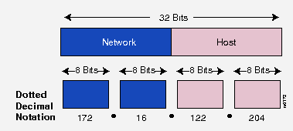

Figure 2.3 Basic Format of IP Address

IP ADDRESS CLASSES
IP addressing supports three different commercial address classes; Class A, Class B, and Class C.
In a class A address, the first octet is the network portion, so the class A address of, 10.1.25.1, has a major network address of 10. Octets 2, 3, and 4 (the next 24 bits) are for the hosts. Class A addresses are used for networks that have more than 65,536 hosts (actually, up to 16,581,375 hosts!).
In a class B address, the first two octets are the network portion, so the class B address of, 172.16.122.204, has a major network address of 172.16. Octets 3 and 4 (the next 16 bits) are for the hosts. Class B addresses are used for networks that have between 256 and 65,536 hosts.
In a class C address, the first three octets are the network portion. The class C address of, 193.18.9.45 has a major network address of 193.18.9. Octet 4 (the last 8 bits) is for hosts. Class C addresses are used for networks with less than 254 hosts.

FIRST-OOCTET RULE
The class of address can be easily determined by examining the first octet of the address, and mapping that value to a class range in the figure below: The left-most (high-order) bits in the first octet indicate the network class
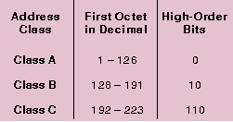

IP SUBNET ADDRESSING:
All Classes of IP networks can be divided into smaller networks called sub networks (or subnets). Dividing the major class network is called subletting. Subletting provides network administrators with several benefits. It provides extra flexibility, makes more efficient use of network address utilization, and contains broadcast traffic because a broadcast will not cross a router. Subnets are under local administration. As such, the outside world sees an organization as a single network, and has no detailed knowledge of the organization's internal network structure. A given network address can be broken up into many sub networks. For example, 172.16.1.0, 172.16.2.0, 172.16.3.0, and 172.16.4.0 are all subnets of the Class B network 171.16.0.0.

THE CLIENT/SERVER MODEL
Most modern network programming is based on a client/server model. A client/server application typically stores large quantities of data on an expensive, high-powered server, while most of the program logic and the user interface is handled by client software running on relatively cheap personal computers. In most cases, a server primarily sends data, while a client primarily receives it, but it is rare for one program to send or receive exclusively. A more reliable distinction is that a client initiates a
Conversation, while a server waits for clients to start conversations with it. Figure 2.5 illustrates both possibilities. In some cases, the same program may be both a client and a server.
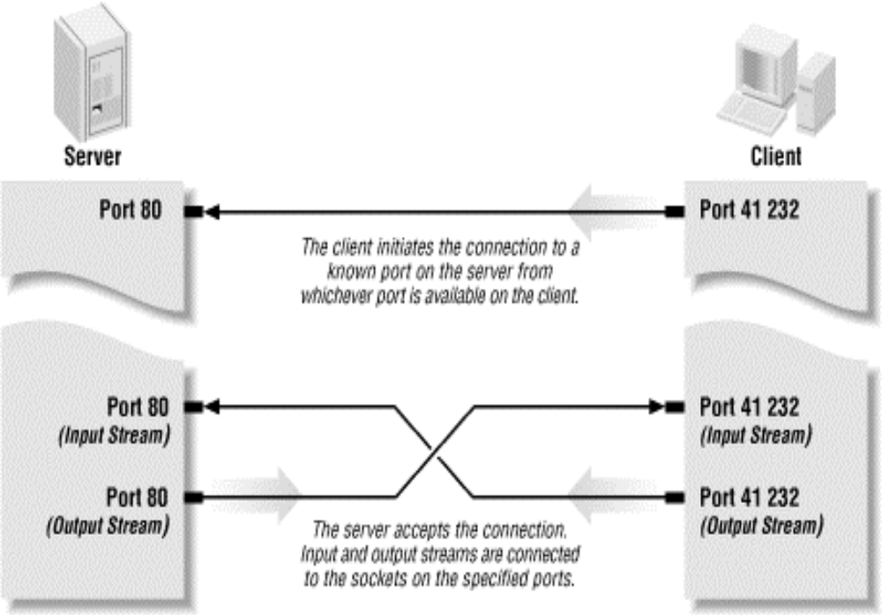

Figure 2.5 Client Server Model
Some servers process and analyze the data before sending the results to the client. Such servers are often referred to as "application servers" to distinguish them from the some server’s process and analyze the data before sending the results to the client. Such servers are often referred to as "application servers" to distinguish them from the more common file servers and database servers. A file or database server will retrieve information and send it to a client, but it won't process that information. In contrast, an application server might look at an order entry database and give the clients reports about monthly sales trends. An application server is not a server that serves files that happen to be applications.
You are already familiar with many examples of client/server systems. In 2000, the most popular client/server system on the Internet is the Web. Web servers such as Apache respond to requests from web clients such as Netscape. Data is stored on the web server and is sent out to the clients that request it. Aside from the initial request for a page, almost all data is transferred from the server to the client, not from the client to the server. Web servers that use CGI programs double as application and file
Servers. An older service that fits the client/server model is FTP. FTP uses different application protocols and different software but is still split into FTP servers, which send files, and FTP clients, which receive files. People often use FTP to upload files from the client to the server, so it's harder to say that the data transfer is primarily in one direction, but it is still true that an FTP client initiates the connection and the FTP server responds to it. Java is a powerful environment in which to write GUI programs that access many different kinds of servers. The preeminent example of a client program written in Java is Hot Java, the web browser from Sun, which is a general-purpose web client. Java makes it easy to write clients of all sorts, but it really shines when you start writing servers. Java does have some performance bottlenecks, mostly centered on GUIs and disk I/O. However, neither of these is a limiting factor for server programs where network bandwidth and robustness are far more important. Not all applications fit easily into a client/server model. For instance, in networked games it seems likely that both players will send data back and forth roughly equally (at least in a fair game). These sorts of connections are called "peer-to-peer". The telephone system is the classic example of a peer-to-peer network. Each phone can either call another phone or be called by another phone. You don't have to buy one
phone to send calls and another to receive them. Java does not have explicit peer-to-peer communication in its networking API. However, applications can easily implement peer-to-peer communications in several
ways, most commonly by acting as both a server and a client. alternatively, the peers can communicate with each other through an intermediate server program that forwards data from one peer to the other peers. This is especially useful for applets whose security manager restricts them from talking directly to each other.
2. 6. TCP/IP UTILITEIES AND TOOLS
Many tools and utilities are available as standard to help administrators manage TCP/IP networks, diagnose faults and track down bottlenecks. Many of these you may have heard of and used, but didn’t understand what was being done. All of the tools mentioned here are command line tools, designed to be run from a DOS window/NT command prompt unless otherwise mentioned.

PORT SCANNERS

A port scanner is the name for a tool that attempts to connect to multiple ports on a specific host or group of hosts and is the general name for tools such as the Shields Up web site. As with whose, none are supplied as
Standard with Windows, but free versions are available on the internet. My own preference is for TCP Scan available for free on the internet, but as always others are available. These can also help find other security holes that you didn’t know about, or processes running on machines.

SOCKET

Communication between two JVM (which may or may not be running on two different physical machines). Socket is an endpoint for communication. There are two kinds of sockets, depending on whether one wishes to use a connectionless or a connection-oriented protocol. The connectionless communication protocol of the Internet is called UDP. The connection-oriented communication protocol of the Internet is called TCP. UDP sockets are also called datagram sockets. Each socket is uniquely identified on the entire Internet with two numbers. The first number is a 128-bit integer called the Internet Address (or IP address). The second number is a 16-bit integer called the port of the socket. The IP address is the location of the machine, which you are trying to connect to and the port number is the port on which the server you are trying to connect is running. The port numbers 0 to 1023 are reserved for standard services such as e-mail, FTP, HTTP etc. The lifetime of the socket is made of 3 phases: Open Socket Read: and Write to Socket: Close Socket
To make a socket connection you need to know two things: An IP address and port on which to listen/connect. In Java you can use the Socket (client side) and Server Socket (Server side) classes.

I/O STREAM
Following are the strong points which performed by I/O Streams in Java.
- Java program performs I/O through Stream.
- Streams are the built-in classes that are reading and writing data anywhere.
- A Stream is an abstraction that either produces or consumes information.
- Stream linked to a physical device by the Java I/O System.
- All Streams behave in same manner, even if the actual physical devices to which they are linked defer.
- I/O classes and Methods can be applied to any type of devices.
- This means that an InputStream an abstract many different kinds of Input: from a disk files, a Keyboard or a Network Socket.
- Like wise, an OutputStream may refer to the Console, a disk files or Network Socket.
- Streams are a clean way to deal with Input/Output without having every part of your code.
- Java approach to Streams is loosely the same as C/C++.
- Java I/O Streams are very powerful that are reading and writing data anywhere.

EXAMPLE READING STRING FROM KEYBOARD
Import java.io.*;
DataInputStream keyboard = new DataInputStream(System.in);
String STR=keyboard.readLine ();
Keyboard

EXAMPLE READING STRING FROM DISK FILE
import java.io.*;
FileInputStream file = new FileInputStream (“abc.txt”);
DataInputStream disk = new DataInputStream(file);
String str=disk.readLine();

Disk File

EXAMPLE READING DATA FROM REMOTE MACHINE

Import java.io.*;
Import java.net.*;
URL url = new URL(“http://www.yahoo.com/index.html”);
InputStream in=url.openStream();

DataInputStream remote = new DataInputStream(in);
String strr=remote.readLine();

Reading Data from Yahoo.com
Yahoo.com
Reading
Internet

FDGDF

EXAMPLE: WRITING STRING ON SCREEN
Import java.io.*;
DataOutputStream console = new DataOutputStream (System.out);
Console.writeBytes(“Hello Students”);

Console Output
Hello Student

EXAMPLE: WRITING STRING ON DISK FILE

Import java.io.*;

FileOutputStream file = new FileOutputStream(“abc.txt”);

DataOutputStream disk = new DataOutputStream(file);
disk.writeBytes(“Hello Students”);

Disk File

EXAMPLE: WRITING DATA ON REMOTE MACHINE
Import java.io.*;
Import java.net.*;

URL url = new URL(“http://www.yahoo.com/index.html”);
URLConnection connection=url.openConnection();
OutputStream os=connection.getOutputStream();
DataOutputStream remote = new DataOutputStream(os);
Remote.writeBytes(“hello Sudents”);
Yahoo.com
Writing
Internet

- Previously programmers were developing heavy and powerful Client/Servers using C/C++ for Mainframe and Super Computers, but now days that type of Clients/Servers can be developed in Java.
- Java Provide java.io Package and java.net Packages, both of these packages creating heavy Business Enterprise Servers.
- Java.net provide approximately 40 classes and interfaces for handling network problems
- Java.io package provides 70 classes and interfaces for reading and writing data from different devices.
- Creators of Java have called Java “programming For Internet”.

Tools And Technologies

Front End Client:
Mobile

User Interfaces
Client (student) on Mobile will be using Android Application

Hardware Requirments
- P-IV or faster Processor.
- Minimum 1GB hard disk space.
- 500 MB of RAM or more.
- Display capable of showing 16 bit colors or more.
- Android Cell Phone

Installtion Requirments
  - Install eclipse android
  - Install Jdk 1.6
IDE:
Name: Eclipse
Source: https://eclipse.org/downloads/
Java:
Name: JDK 1.7.0
Version: 1.7.0

Constraint
- GUI is only in English
- Roll number and card number is used for the pay fees of student.

PROBLEM DESCRIPTION

UML (UNIFIED MODELING LANGUAGE) DIAGRAMS:
The application comprises various UML (Unified Modeling Language) diagrams including use case, class, sequence, collaboration and activity diagrams.

USE CASE DIAGRAM
Use case diagram of the application represents functional requirement of the system and depict the actions that are allowed by the application to the user to perform. The detailed use case diagram of the application as illustrated as under
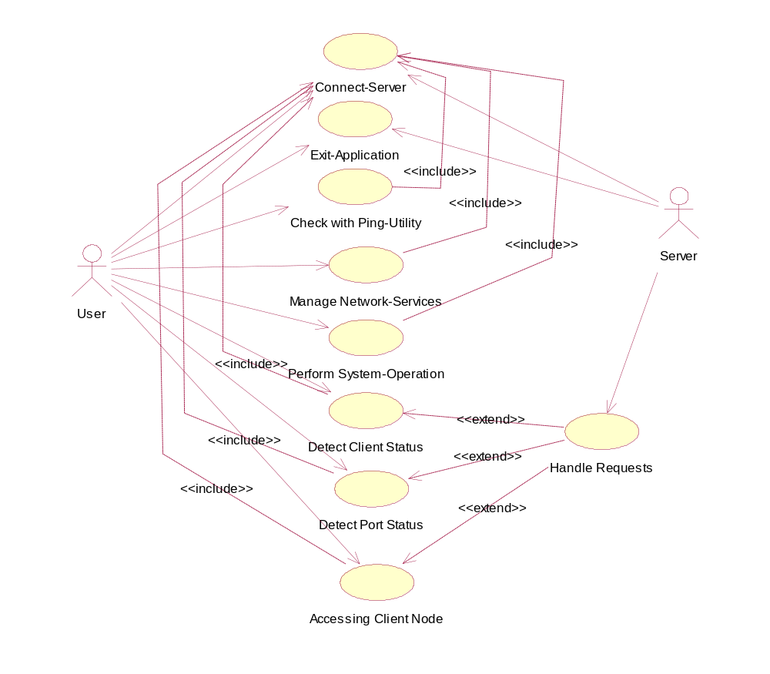Figure 3.1: Application Use case Diagram

Use Case-1

design and implementation

Architecture Diagram

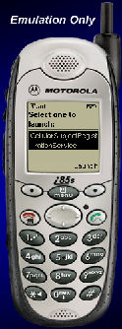

Android Clients

Android Clients

Network peer making request for registration

Buffer for peer list

Each online peer required registration it is minimum requirement of calling Service.

Any peer who has calling to cell phone number, required registration with registry service once peer registered, registry service update the peer list and re-transmit to all online connected peers. The responsibility of Registry Service is to provide Naming Service based on TCP working transport layer but in the application layer
When any peer offline another words disconnected with registry service, registry service remove registered name from buffer updates and re-transmit remaining peer names to all other connected peers.
Wi-Fi Chat Engine based on custom protocol, but here custom protocol working on the top UDP, Wi-Fi process working 100% proper and reliable, due to use of custom protocol with UDP, this approach is more suitable compare TCP on transport level, this approach consumes less bandwidth there will be no permanents connection required between peers, all the network peers are free all the time because here custom protocol switch the transport level protocol and choose UDP for Wi-Fi.

Main Page Of Application
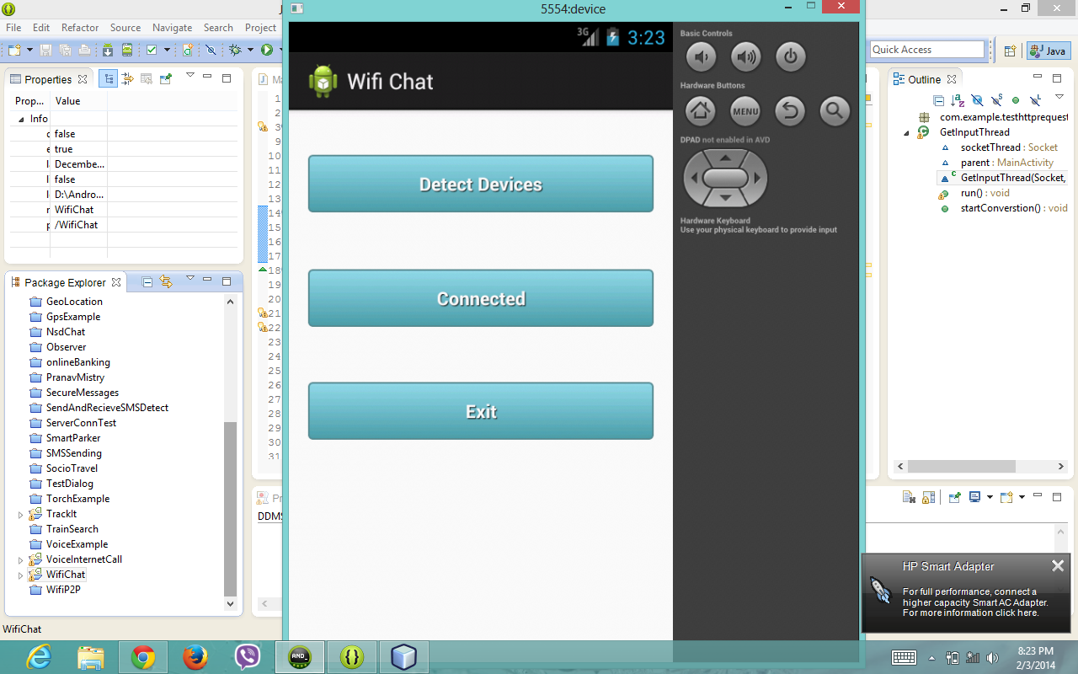
Figure 4.4.1: Detect and Connect Device
Description: Figure 4.4.1 shows that Main Page of Application

Detect Device
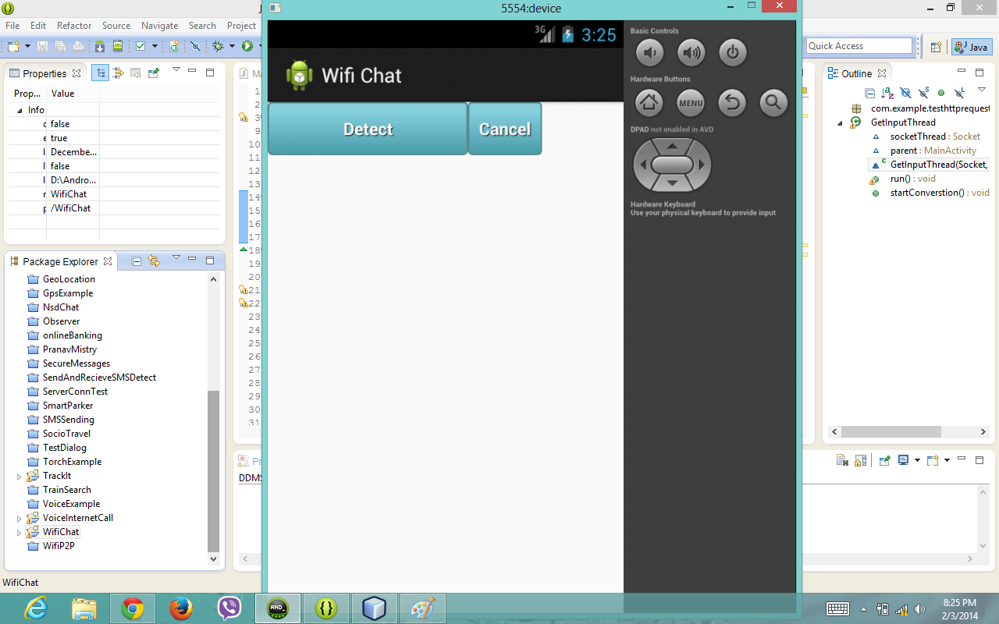
Figure 4.4.2: Detect Devices Shows

Description: Figure 4.4.2 shows that detect the devices it means shows the online clients.

Result Of Detect Devices

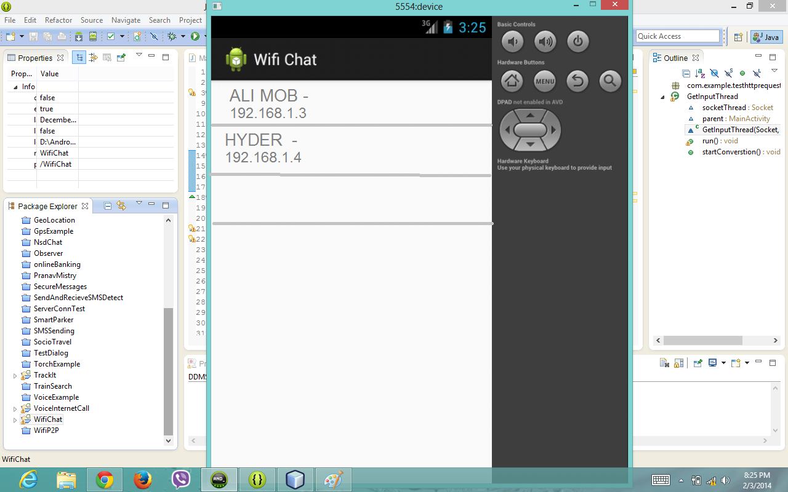
Figure 4.4.1: shows the devices

Description: Figure 4.5.1 shows the all mobile phones and computers those are connected with Wi-Fi.

Response Of Exam Result
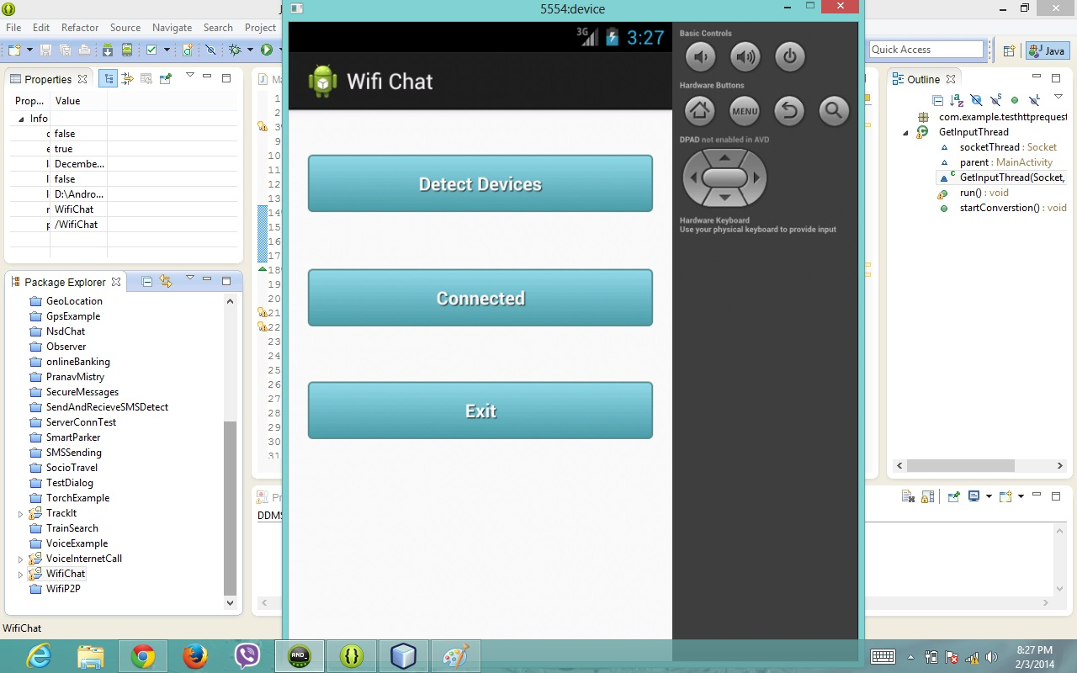
Figure 4.5.2: Reply of exam result

Description: Figure 4.5.2 shows that Student will see on mobile information of semester result.

CONCLUSION AND FUTURE WORK

CONCLUSION
A Wi-Fi is a new approach for local communications in mobile world. Wi-Fi proximity is a main idea behind Wi-Fi chat. If you and your potential pal can see at this moment the same Wi-Fi access point (Wi-Fi network) than it is very probably that you can see each other. In other words, it is very likely that you are close to each other. Close in the geographical sense, of course. So, WIFI CHAT lets you create discussions (forums) as well as live web chats associated with Wi-Fi access points. It is yet another way to create hyper- local group messaging.

It is concluded that the software that allow to user This application provide the interface for search clients, if the wifi is enabled the user will chat through local area network
It is also concluded that NETWORK SECURITY is designed in such as manner that it costs less and provides a lot of benefits. Its hardware and software requirements are cheep and available in the market.

FUTURE WORK
At this time the application is developed for local area network environment. if God will we will implements for global area network.

glosery
GLOSSARY

A

Analysis
The part of the software development process whose primary purpose is to formulate a model of the problem domain. Analysis focuses what to do, design focuses on how to do it.

Architecture
The organizational structure of a system. An architecture can be recursively decomposed into parts that interact through interfaces, relationships that connect parts, and constraints for assembling parts.

.

B

Behavior
The observable effects of an operation or event, including its results.

Binary association
An association between two classes. A special case of an n-ary association.

C

Component
An executable software module with identity and a well-defined interface.

Context
A view of a set of related modeling elements for a particular purpose, such as specifying an operation.

D

Delegation
The ability of an object to issue a message to another object in response to a message. Delegation can be used as an alternative to inheritance.

Dependency
A relationship between two modeling elements, in which a change to one modeling element (the independent element) will affect the other modeling element (the dependent element).

Deployment diagram
A diagram that shows the configuration of run-time processing nodes and the components, processes, and objects that live on them. Components represent run-time manifestations of code units.

Derived element
A model element that can be computed from another element, but that is shown for clarity or that is included for design purposes even though it adds no semantic information.

E

Extends
A relationship from one use case to another, specifying how the behavior defined for the first use case can be inserted into the behavior defined for the second use case.

G

Generalization
A taxonomic relationship between a more general element and a more specific element. The more specific element is fully consistent with the more general element and contains additional information.

I

Implementation
A definition of how something is constructed or computed. For example, a class is an implementation of a type, a method is an implementation of an operation.

Interaction
A specification of how messages are sent between instances to perform a specific task. The interaction is defined in the context of a collaboration.

Interface
A declaration of a collection of operations that may be used for defining a service offered by an instance.

M

Model
A semantically closed abstraction of a system.

Module
A software unit of storage and manipulation. Modules include source code modules, binary code modules, and executable code modules.

0

Object diagram
A diagram that encompasses objects and their relationships at a point in time. An object diagram may be considered a special case of a class diagram or a collaboration diagram.

Object lifeline
A line in a sequence diagram that represents the existence of an object over a period of time.

Operation
A service that can be requested from an object to effect behavior. An operation has a signature, which may restrict the actual parameters that are possible.

R

Relationship
A semantic connection among model elements. Examples of relationships include associations and generalizations.

S

Specification
A declarative description of what something is or does.

Structural feature
A static feature of a model element, such as an attribute.

U

Use case
The specification of a sequence of actions, including variants, that a system (or other entity) can perform, interacting with actors of the system.

Use case diagram
A diagram that shows the relationships among actors and use cases within a system.

Use case instance
The performance of a sequence of actions being specified in a use case. An instance of a use case.

Use case model
A model that describes a system’s functional requirements in terms of use cases.

Uses
A relationship from a use case to another use case in which the behavior defined for the former use case employs the behavior defined for the latter.

BIBLIOGRAPHY

[Mastering]
Mastering Java2

[How to program]
How to program Java

[Black]
Black Java2

[Wrox]
Java2 (Programmer to programmer)

[Inside]
Inside Java2

[M .Net]
Mastering Java2

[Complete Reference]
Java2 (Complete Reference)

ABBREVIATIONS

API Application Programming Interface
HTML Hyper Text Markup Language
TCP Transmission Control Protocol
TCP/IP Transmission Control Protocol/Internet Protocol
TLS Transport Layer Security
UDP User Datagram Protocol
URL Uniform Resource Locator
URN Uniform Resource Name

